**CHAPTER 7**

**PYTHON OOPS**

**Introduction to OOPs in Python**

Python is a multi-paradigm programming language. Meaning, it supports different programming approach. One of the popular approach to solve a programming problem is by creating objects. This is known as Object-Oriented Programming (OOP).

An object has two characteristics:

* attributes
* behavior

Let's take an example:

Parrot is an object,

* name, age, color are attributes
* singing, dancing are behavior

The concept of OOP in Python focuses on creating reusable code. This concept is also known as DRY (Don't Repeat Yourself). In Python, the concept of OOP follows some basic principles:

|  |  |
| --- | --- |
| Inheritance | A process of using details from a new class without modifying existing class. |
| Encapsulation | Hiding the private details of a class from other objects. |
| Polymorphism | A concept of using common operation in different ways for different data input. |

**Class**

A class is a blueprint for the object. We can think of class as an sketch of a parrot with labels. It contains all the details about the name, colors, size etc. Based on these descriptions, we can study about the parrot. Here, parrot is an object. The example for class of parrot can be :

class Parrot

pass

Here, we use class keyword to define an empty class Parrot. From class, we construct instances. An instance is a specific object created from a particular class.

**Object**

An object (instance) is an instantiation of a class. When class is defined, only the description for the object is defined. Therefore, no memory or storage is allocated. The example for object of parrot class can be:

obj = Parrot()

Here, obj is object of class Parrot. Suppose we have details of parrot. Now, we are going to show how to build the class and objects of parrot.

**Example 1: Creating Class and Object in Python**

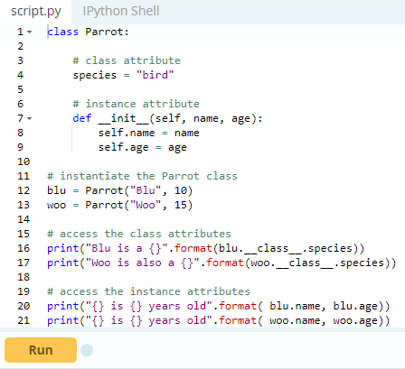

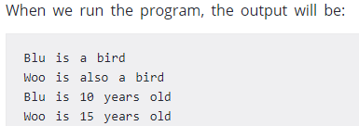

In the above program, we create a class with name Parrot. Then, we define attributes. The attributes are a characteristic of an object. Then, we create instances of the Parrot class. Here, blu and woo are references (value) to our new objects.

Then, we access the class attribute using __class __.species. Class attributes are same for all instances of a class. Similarly, we access the instance attributes using blu.name and blu.age. However, instance attributes are different for every instance of a class.

To learn more about classes and objects, go to [Python Classes and Objects](https://www.programiz.com/python-programming/class)

## Methods

Methods are functions defined inside the body of a class. They are used to define the behaviors of an object.

### Example 2 : Creating Methods in Python

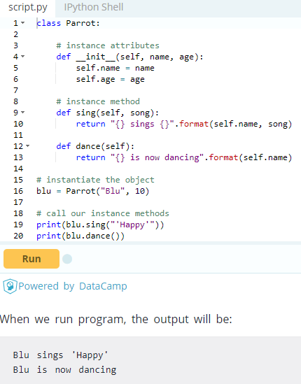

In the above program, we define two methods i.e sing() and dance(). These are called instance method because they are called on an instance object i.e blu.

## Inheritance

Inheritance is a way of creating new class for using details of existing class without modifying it. The newly formed class is a derived class (or child class). Similarly, the existing class is a base class (or parent class).

### **Example 3: Use of Inheritance in Python**

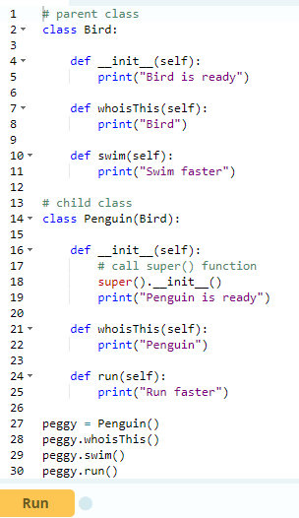

When we run this program, the output will be:

Bird is ready

Penguin is ready

Penguin

Swim faster

Run faster

In the above program, we created two classes i.e. Bird (parent class) and Penguin (child class). The child class inherits the functions of parent class. We can see this from swim()method. Again, the child class modified the behavior of parent class. We can see this from whoisThis() method. Furthermore, we extend the functions of parent class, by creating a new run() method.

Additionally, we use super() function before __init__() method. This is because we want to pull the content of __init__() method from the parent class into the child class.

## Encapsulation

Using OOP in Python, we can restrict access to methods and variables. This prevent data from direct modification which is called encapsulation. In Python, we denote private attribute using underscore as prefix i.e single “ _ “ or double “ __“.

### **Example 4: Data Encapsulation in Python**

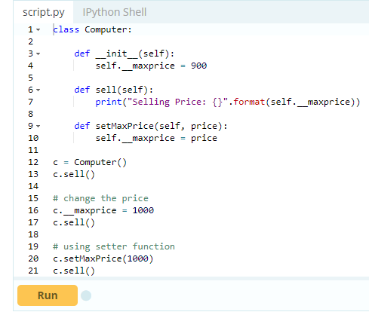

When we run this program, the output will be:

Selling Price: 900

Selling Price: 900

Selling Price: 1000

In the above program, we defined a class Computer. We use __init__() method to store the maximum selling price of computer. We tried to modify the price. However, we can’t change it because Python treats the __maxprice as private attributes. To change the value, we used a setter function i.e setMaxPrice() which takes price as parameter.

## Polymorphism

Polymorphism is an ability (in OOP) to use common interface for multiple form (data types). Suppose, we need to color a shape, there are multiple shape option (rectangle, square, circle). However we could use same method to color any shape. This concept is called Polymorphism.

### **Example 5: Using Polymorphism in Python**

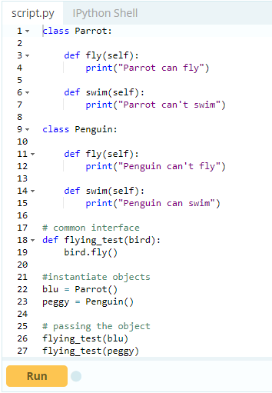

When we run above program, the output will be:

Parrot can fly

Penguin can't fly

In the above program, we defined two classes Parrot and Penguin. Each of them have common method fly() method. However, their functions are different. To allow polymorphism, we created common interface i.e flying_test() function that can take any object. Then, we passed the objects blu and peggy in the flying_test() function, it ran effectively.

## Key Points to Remember:

* The programming gets easy and efficient.
* The class is sharable, so codes can be reused.
* The productivity of programmers increases
* Data is safe and secure with data abstraction.

# **Python Objects and Class**

## What are classes and objects in Python?

Python is an object oriented programming language. Unlike procedure oriented programming, where the main emphasis is on functions, object oriented programming stress on objects.

Object is simply a collection of data (variables) and methods (functions) that act on those data. And, class is a blueprint for the object.

We can think of class as a sketch (prototype) of a house. It contains all the details about the floors, doors, windows etc. Based on these descriptions we build the house. House is the object.

As, many houses can be made from a description, we can create many objects from a class. An object is also called an instance of a class and the process of creating this object is called **instantiation**.

## Defining a Class in Python

Like function definitions begin with the keyword [def](https://www.programiz.com/python-programming/keyword-list#def), in Python, we define a class using the keyword [class](https://www.programiz.com/python-programming/keyword-list#class). The first string is called docstring and has a brief description about the class. Although not mandatory, this is recommended.

Here is a simple class definition.

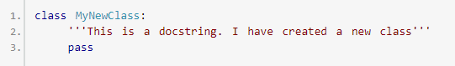

A class creates a new local [namespace](https://www.programiz.com/python-programming/namespace) where all its attributes are defined. Attributes may be data or functions. There are also special attributes in it that begins with double underscores (__). For example, __doc__ gives us the docstring of that class. As soon as we define a class, a new class object is created with the same name. This class object allows us to access the different attributes as well as to instantiate new objects of that class.

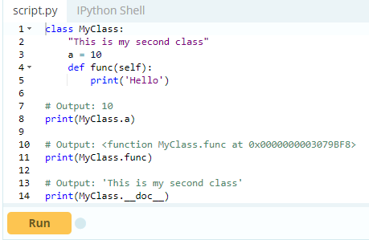

When you run the program, the output will be:

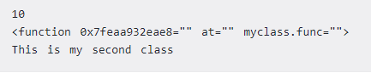

## Creating an Object in Python

We saw that the class object could be used to access different attributes. It can also be used to create new object instances (instantiation) of that class. The procedure to create an object is similar to a [function](https://www.programiz.com/python-programming/function)call.

1. >>> ob = MyClass()

This will create a new instance object named ob. We can access attributes of objects using the object name prefix. Attributes may be data or method. Method of an object are corresponding functions of that class. Any function object that is a class attribute defines a method for objects of that class. This means to say, since MyClass.func is a function object (attribute of class), ob.func will be a method object.

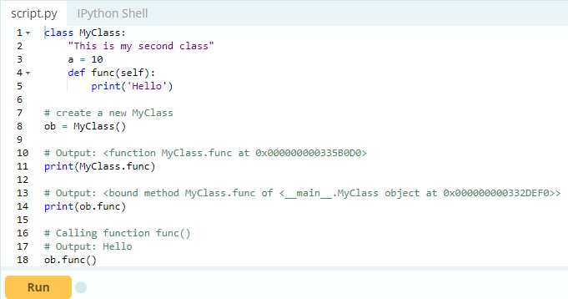

You may have noticed the self parameter in function definition inside the class but, we called the method simply as ob.func() without any [arguments](https://www.programiz.com/python-programming/function-argument). It still worked. This is because, whenever an object calls its method, the object itself is passed as the first argument. So, ob.func() translates into MyClass.func(ob).

In general, calling a method with a list of n arguments is equivalent to calling the corresponding function with an argument list that is created by inserting the method's object before the first argument.

For these reasons, the first argument of the function in class must be the object itself. This is conventionally called self. It can be named otherwise but we highly recommend to follow the convention. Now you must be familiar with class object, instance object, function object, method object and their differences.

## Constructors in Python

Class functions that begins with double underscore (__) are called special functions as they have special meaning. Of one particular interest is the __init__() function. This special function gets called whenever a new object of that class is instantiated.

This type of function is also called constructors in Object Oriented Programming (OOP). We normally use it to initialize all the variables.

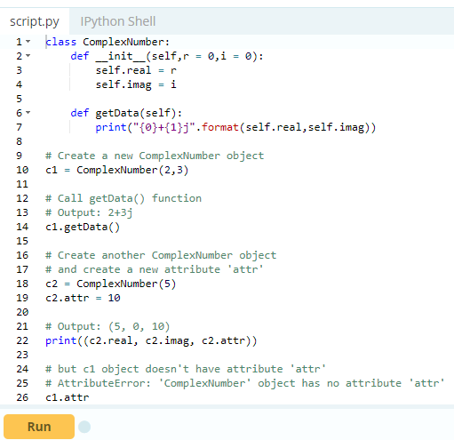

In the above example, we define a new class to represent complex numbers. It has two functions, __init__() to initialize the variables (defaults to zero) and getData() to display the number properly.

An interesting thing to note in the above step is that attributes of an object can be created on the fly. We created a new attribute attr for object c2 and we read it as well. But this did not create that attribute for object c1.

## Deleting Attributes and Objects

Any attribute of an object can be deleted anytime, using the del statement. Try the following on the Python shell to see the output.

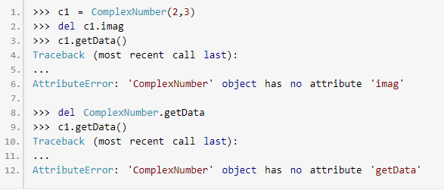

We can even delete the object itself, using the del statement.

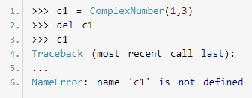

Actually, it is more complicated than that. When we do c1 = ComplexNumber(1,3), a new instance object is created in memory and the name c1 binds with it.

On the command del c1, this binding is removed and the name c1 is deleted from the corresponding namespace. The object however continues to exist in memory and if no other name is bound to it, it is later automatically destroyed. This automatic destruction of unreferenced objects in Python is also called garbage collection.

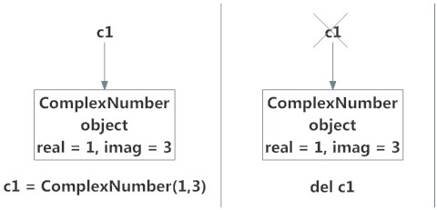

# **Python Inheritance**

## What is Inheritance?

Inheritance is a powerful feature in object oriented programming. It refers to defining a new [class](https://www.programiz.com/python-programming/class) with little or no modification to an existing class. The new class is called **derived (or child) class** and the one from which it inherits is called the **base (or parent) class**.

### Python Inheritance Syntax

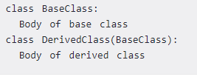

Derived class inherits features from the base class, adding new features to it. This results into re-usability of code. Example of Inheritance in Python To demonstrate the use of inheritance, let us take an example.

A polygon is a closed figure with 3 or more sides. Say, we have a class called Polygon defined as follows.

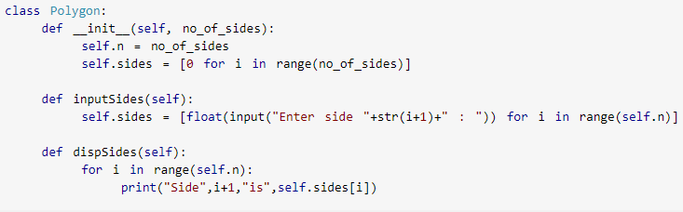

This class has data attributes to store the number of sides, n and magnitude of each side as a list, sides. Method inputSides() takes in magnitude of each side and similarly, dispSides() will display these properly.

A triangle is a polygon with 3 sides. So, we can created a class called Triangle which inherits from Polygon. This makes all the attributes available in class Polygon readily available in Triangle. We don't need to define them again (code re-usability). Triangle is defined as follows.

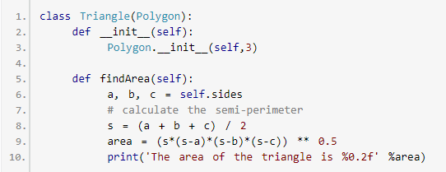

However, class Triangle has a new method find Area() to find and print the area of the triangle. Here is a sample run.

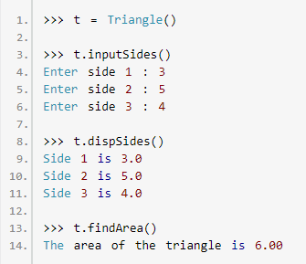

We can see that, even though we did not define methods like inputSides() or dispSides()for class Triangle, we were able to use them. If an attribute is not found in the class, search continues to the base class. This repeats recursively, if the base class is itself derived from other classes.

## Method Overriding in Python

In the above example, notice that __init__() method was defined in both classes, Triangleas well Polygon. When this happens, the method in the derived class overrides that in the base class. This is to say, __init__() in Triangle gets preference over the same in Polygon.

Generally when overriding a base method, we tend to extend the definition rather than simply replace it. The same is being done by calling the method in base class from the one in derived class (calling Polygon.__init__() from __init__() in Triangle).

A better option would be to use the built-in function super(). So, super().__init__(3) is equivalent to Polygon.__init__(self,3) and is preferred. You can learn more about the [super() function in Python](http://rhettinger.wordpress.com/2011/05/26/super-considered-super/).

Two built-in functions isinstance() and issubclass() are used to check inheritances. Function isinstance() returns True if the object is an instance of the class or other classes derived from it. Each and every class in Python inherits from the base class object.

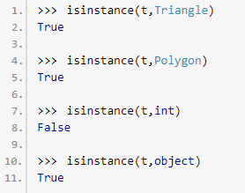

Similarly, is subclass() is used to check for class inheritance.

# 

# **Python Multiple Inheritance**

## Multiple Inheritance in Python

Like C++, a [class](https://www.programiz.com/python-programming/class) can be derived from more than one base classes in Python. This is called multiple inheritance. In multiple inheritance, the features of all the base classes are inherited into the derived class. The syntax for multiple inheritance is similar to single [inheritance](https://www.programiz.com/python-programming/inheritance).

### Example

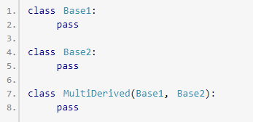

Here, Multi Derived is derived from classes Base1 and Base2.

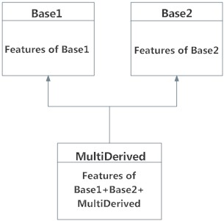

The class MultiDerived inherits from both Base1 and Base2.

## Multilevel Inheritance in Python

On the other hand, we can also inherit form a derived class. This is called multilevel inheritance. It can be of any depth in Python.

In multilevel inheritance, features of the base class and the derived class is inherited into the new derived class. An example with corresponding visualization is given below.

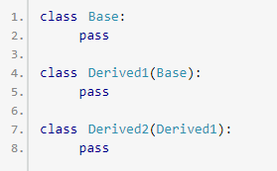

Here, Derived1 is derived from Base, and Derived2 is derived from Derived1.

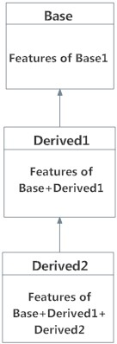

## Method Resolution Order in Python

Every class in Python is derived from the class object. It is the most base type in Python. So technically, all other class, either built-in or user-defines, are derived classes and all objects are instances of object class.

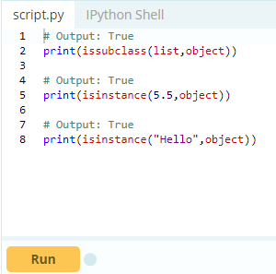

In the multiple inheritance scenario, any specified attribute is searched first in the current class. If not found, the search continues into parent classes in depth-first, left-right fashion without searching same class twice.

So, in the above example of MultiDerived class the search order is [MultiDerived, Base1, Base2, object]. This order is also called linearization of MultiDerived class and the set of rules used to find this order is called **Method Resolution Order (MRO).**

MRO must prevent local precedence ordering and also provide monotonicity. It ensures that a class always appears before its parents and in case of multiple parents, the order is same as tuple of base classes. MRO of a class can be viewed as the __mro__ attribute or mro() method. The former returns a tuple while latter returns a list.

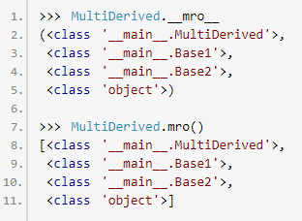

Here is a little more complex multiple inheritance example and its visualization along with the MRO.

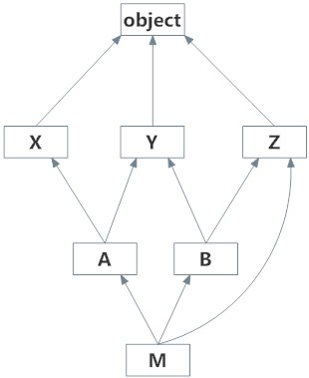

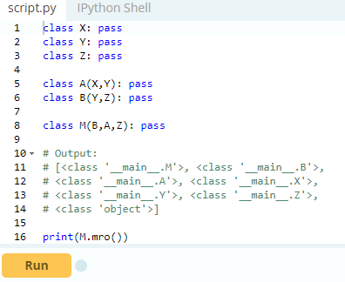

Refer to this, for further [discussion on MRO](http://www.python.org/download/releases/2.3/mro/) and to know the actual algorithm how it is calculated.

# **Python Operator Overloading**

[Python operators](https://www.programiz.com/python-programming/operators) work for built-in classes. But same operator behaves differently with different types. For example, the + operator will, perform arithmetic addition on two numbers, merge two lists and concatenate two strings.

This feature in Python, that allows same operator to have different meaning according to the context is called operator overloading. So what happens when we use them with objects of a user-defined class? Let us consider the following class, which tries to simulate a point in 2-D coordinate system.

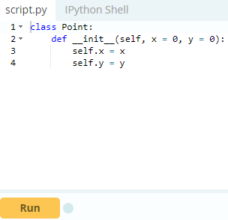

Now, run the code and try to add two points in Python shell.

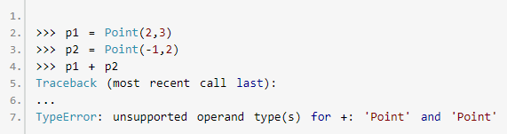

Whoa! That's a lot of complains. TypeError was raised since Python didn't know how to add two Point objects together.

However, the good news is that we can teach this to Python through operator overloading. But first, let's get a notion about special functions.

## Special Functions in Python

Class functions that begins with double underscore __ are called special functions in Python. This is because, well, they are not ordinary. The __init__() function we defined above, is one of them. It gets called every time we create a new object of that class. There are a ton of [special functions in Python](http://docs.python.org/3/reference/datamodel.html#special-method-names).

Using special functions, we can make our class compatible with built-in functions.

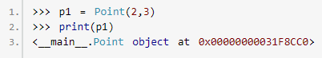

That did not print well. But if we define __str__() method in our class, we can control how it gets printed. So, let's add this to our class.

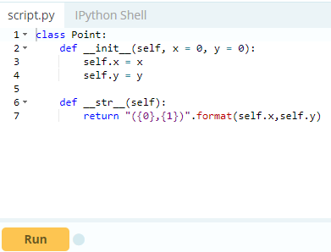

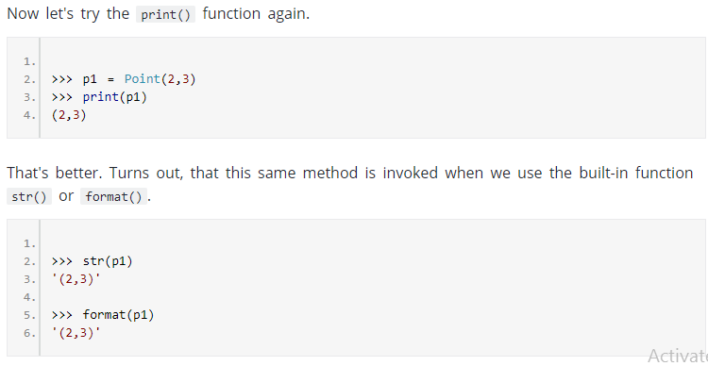

So, when you do str(p1) or format(p1), Python is internally doing p1.__str__(). Hence the name, special functions. Ok, now back to operator overloading.

## Overloading the + Operator in Python

To overload the + sign, we will need to implement __add__() function in the class. With great power comes great responsibility. We can do whatever we like, inside this function. But it is sensible to return a Point object of the coordinate sum.

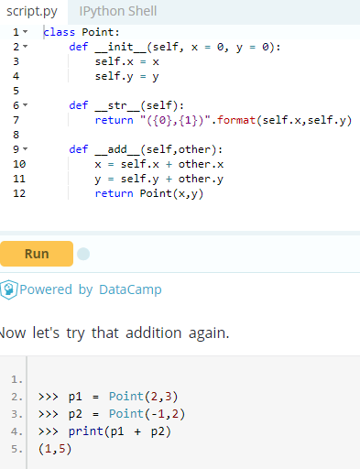

What actually happens is that, when you do p1 + p2, Python will call p1.__add__(p2) which in turn is Point.__add__(p1,p2). Similarly, we can overload other operators as well. The special function that we need to implement is tabulated below.

**Operator Overloading Special Functions in Python**

|  |  |  |
| --- | --- | --- |
| Operator | Expression | Internally |
| Addition | p1 + p2 | p1.__add__(p2) |
| Subtraction | p1 - p2 | p1.__sub__(p2) |
| Multiplication | p1 * p2 | p1.__mul__(p2) |
| Power | p1 ** p2 | p1.__pow__(p2) |
| Division | p1 / p2 | p1.__truediv__(p2) |
| Floor Division | p1 // p2 | p1.__floordiv__(p2) |
| Remainder (modulo) | p1 % p2 | p1.__mod__(p2) |
| Bitwise Left Shift | p1 << p2 | p1.__lshift__(p2) |
| Bitwise Right Shift | p1 >> p2 | p1.__rshift__(p2) |
| Bitwise AND | p1 & p2 | p1.__and__(p2) |
| Bitwise OR | p1 | p2 | p1.__or__(p2) |
| Bitwise XOR | p1 ^ p2 | p1.__xor__(p2) |
| Bitwise NOT | ~p1 | p1.__invert__() |
|  | | |

Python does not limit operator overloading to arithmetic operators only. We can overload comparison operators as well. Suppose, we wanted to implement the less than symbol < symbol in our Point class. Let us compare the magnitude of these points from the origin and return the result for this purpose. It can be implemented as follows.

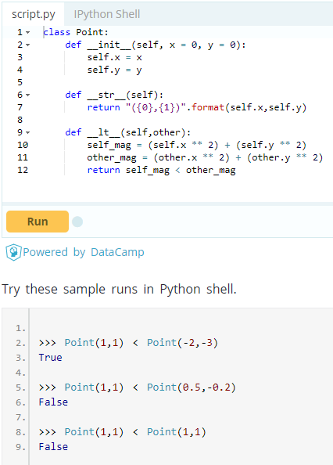

Similarly, the special functions that we need to implement, to overload other comparison operators are tabulated below.

|  |  |  |
| --- | --- | --- |
| Operator | Expression | Internally |
| Less than | p1 < p2 | p1.__lt__(p2) |
| Less than or equal to | p1 <= p2 | p1.__le__(p2) |
| Equal to | p1 == p2 | p1.__eq__(p2) |
| Not equal to | p1 != p2 | p1.__ne__(p2) |
| Greater than | p1 > p2 | p1.__gt__(p2) |
| Greater than or equal to | p1 >= p2 | p1.__ge__(p2) |
|  | | |